**Sri Lanka Institute of Information Technology**



Milestone 5

**User Experience Engineering – IT3050**

B.Sc. (Hons) in Information Technology

Group: SER026_WEEKEND

Sustainable Development Goal: Life Below Water

|  |  |
| --- | --- |
| **Student ID** | **Student Name** |
| IT20281564 | M.T Sanju |
| IT20039004 | H.C Liyanage |
| IT20047542 | W.M.K.K.B Walisundara |
| IT20206550 | K.I.K.R.D.N. Kandakkulama |

Prototype Working Link – <https://www.figma.com/file/MRMh9vzXuHbILwv6JqwrFP/UEE?node-id=1%3A2>

**IT20281564 M.T Sanju**

Updated UI

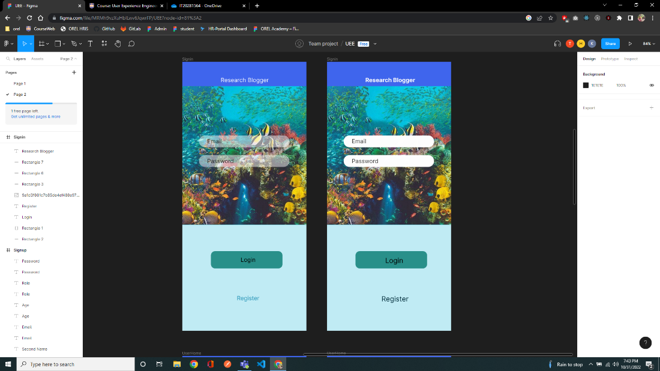

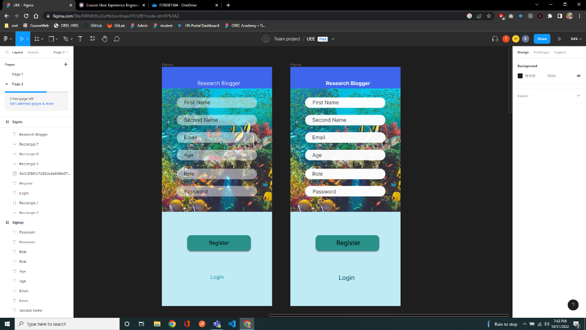

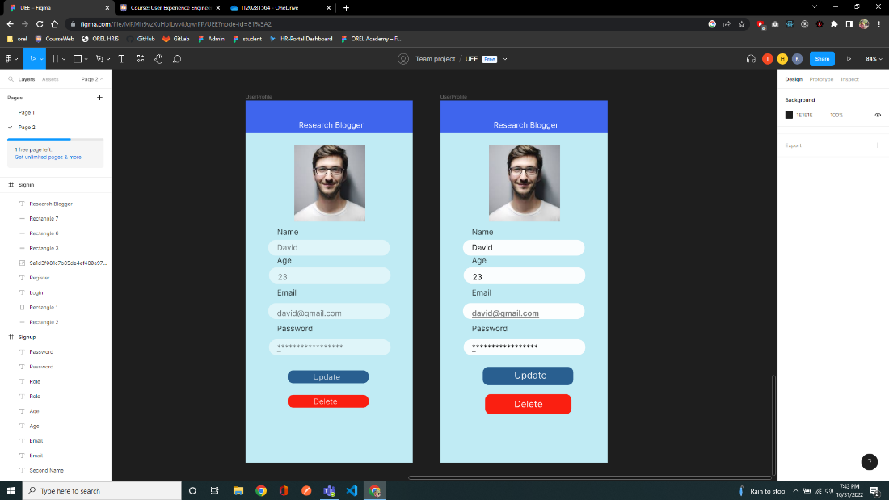

Feedback Video Link:

[Milestone5_UserFeedbackVideos](https://mysliit-my.sharepoint.com/:f:/g/personal/it20281564_my_sliit_lk/ErirXqycZbBEkWEjqDx5q-YByaqekyO6TemofLviSx9H2w?e=ILo9cZ)

User Flow Prototype Link : <https://www.figma.com/proto/MRMh9vzXuHbILwv6JqwrFP/UEE?node-id=1%3A2&scaling=scale-down&page-id=0%3A1&starting-point-node-id=1%3A2&show-proto-sidebar=1>

**IT20039004**

Updated UI

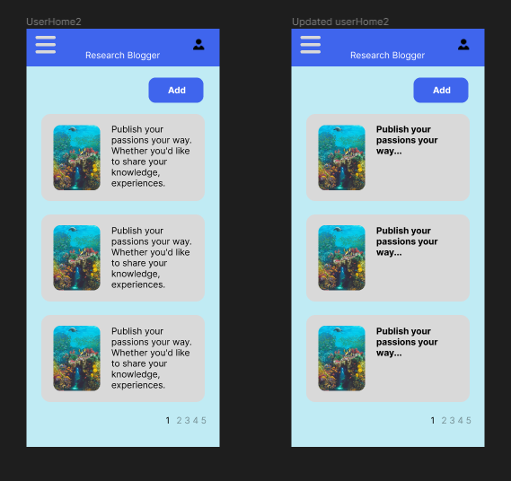

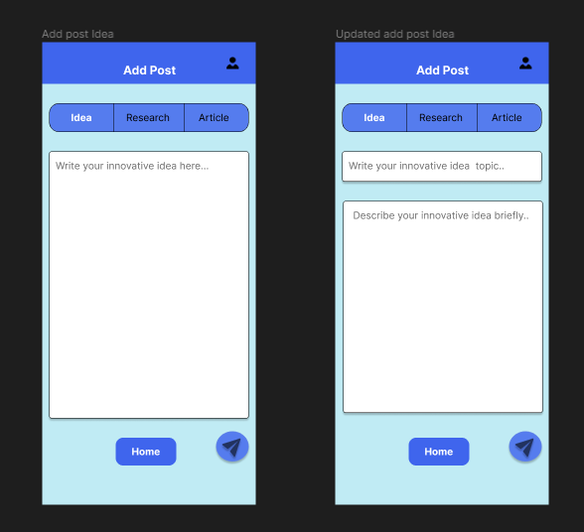

Feedback Video Link [Milestone5_UserFeedbackVideos](https://mysliit-my.sharepoint.com/:f:/g/personal/it20281564_my_sliit_lk/ErirXqycZbBEkWEjqDx5q-YByaqekyO6TemofLviSx9H2w?e=ILo9cZ)

User Flow Prototype Link :- <https://www.figma.com/proto/MRMh9vzXuHbILwv6JqwrFP/UEE?node-id=21%3A119&scaling=scale-down&page-id=0%3A1&starting-point-node-id=21%3A119&show-proto-sidebar=1>

**IT20047542**

Updated UI

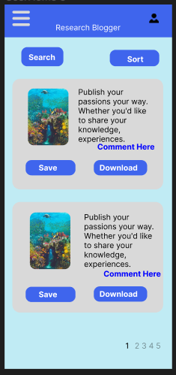

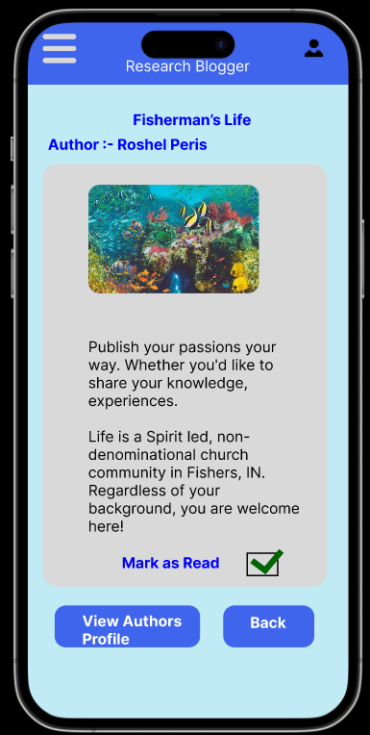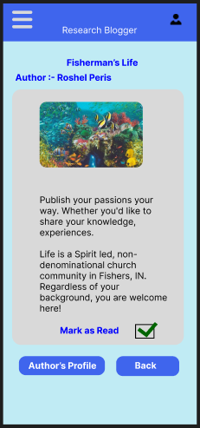

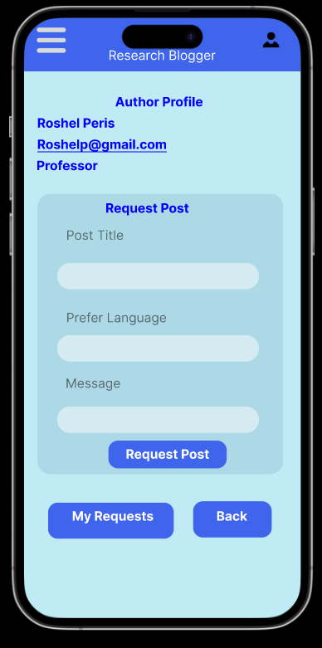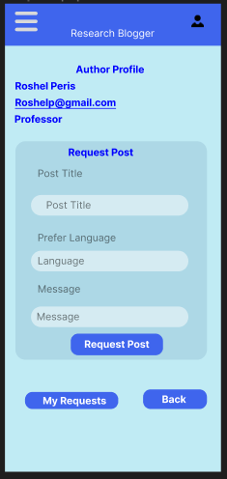

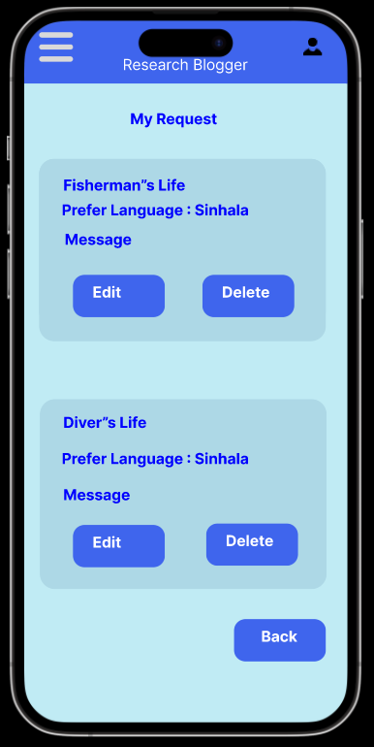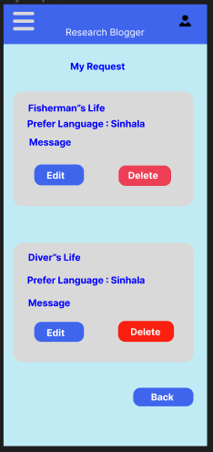

Feedback Video Link [Milestone5_UserFeedbackVideos](https://mysliit-my.sharepoint.com/:f:/g/personal/it20281564_my_sliit_lk/ErirXqycZbBEkWEjqDx5q-YByaqekyO6TemofLviSx9H2w?e=ILo9cZ)

User Flow Prototype Link:- <https://www.figma.com/proto/MRMh9vzXuHbILwv6JqwrFP/UEE?node-id=82%3A9&scaling=scale-down&page-id=0%3A1&starting-point-node-id=82%3A9&show-proto-sidebar=1>

**IT20206550**

Updated UI

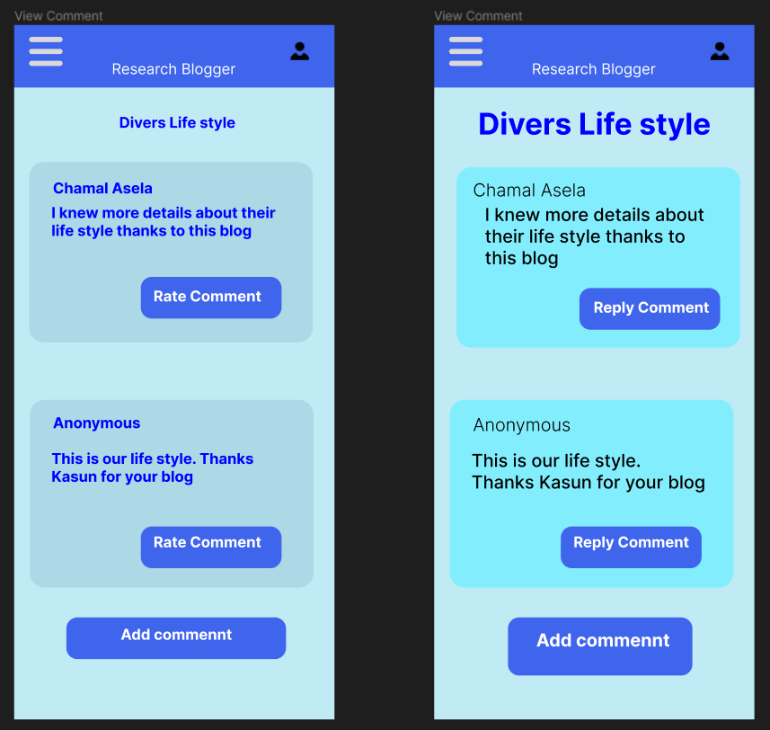

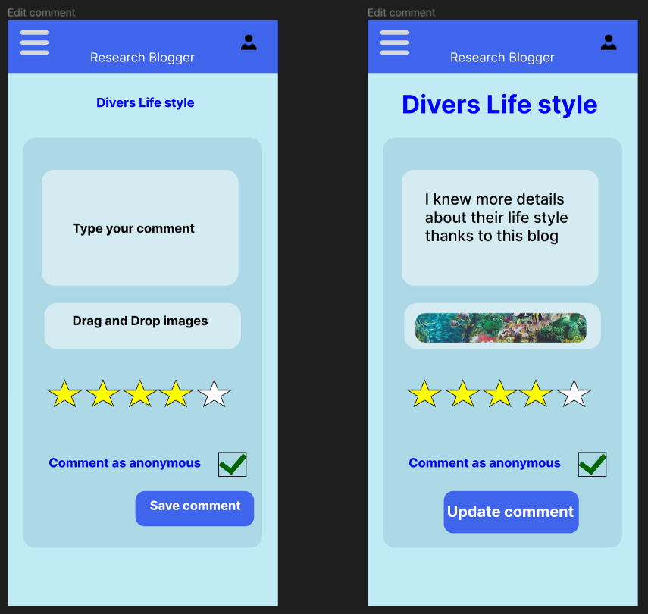

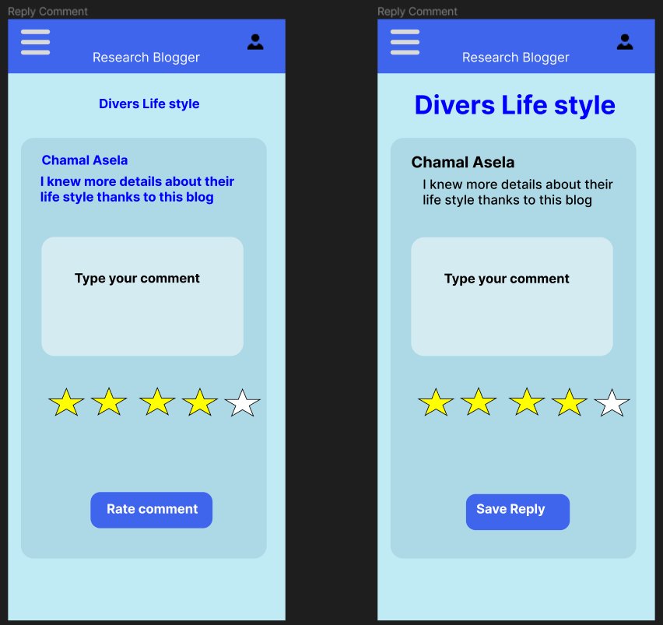

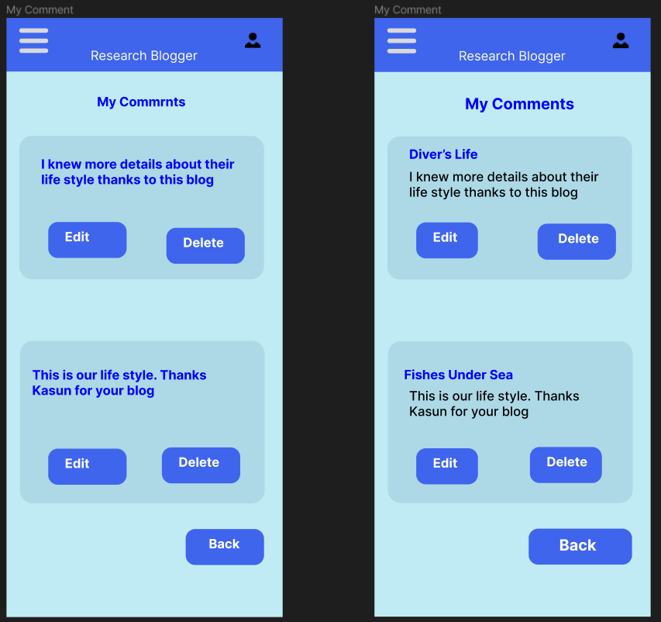

Feedback Video Link: [Milestone5_UserFeedbackVideos](https://mysliit-my.sharepoint.com/:f:/g/personal/it20281564_my_sliit_lk/ErirXqycZbBEkWEjqDx5q-YByaqekyO6TemofLviSx9H2w?e=ILo9cZ)

User Flow Prototype Link:

<https://www.figma.com/proto/MRMh9vzXuHbILwv6JqwrFP/UEE?node-id=81%3A183&scaling=scale-down&page-id=0%3A1&starting-point-node-id=81%3A183&show-proto-sidebar=1>